Directions to Grand Lake Lodge:

From Denver International Airport
From Pena Blvd, go West on I-70 for about 55 miles. Exit North on US 40. This will take you over Berthoud Pass and through Winter Park. At Granby, take US Hwy. 34 North to Grand Lake. The driveway is 1/2 mile north of the village of Grand Lake (it will be on right side of road). You will pass the entrance sign to the national park, but if you pass the visitor center, you have gone too far.

From Estes Park
Take US Hwy. 34 (Trail Ridge Road) through Rocky Mountain National Park. This will take you past the Alpine Visitor Center and over Milner Pass. After you exit the national park, the Grand Lake Lodge is 1/2 mile south of the Visitor Center (it will be on left side of road). If you get to the town of Grand Lake, you have gone too far.

Home James Shuttle Service can transport you directly from the airport to Grand Lake if you choose not to rent a car (800-451-4844).

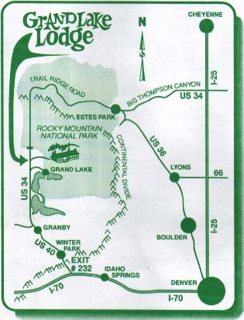

Lodging:

We have reserved lovely cabins at the wedding ceremony and reception site at Grand Lake Lodge (www.grandlakelodge.com, 970-627-3967). Rooms include breakfast and are rented quickly at the Lodge, so please reserve by May. You can ask for rooms reserved for the Graber/Ladek wedding.

Additional information on lodging can be found at http://www.grandlakechamber.com/.

Activities:

Activities at Grand Lake abound, such as white water rafting, horseback riding, boating, golf, and hiking. We will be planning numerous activities throughout the week before the wedding, including hiking, camping, sailing, and social gatherings, and invite you to join us! For additional information, visit our website at www.danaandstephen.com.

Please remember that nights in the Colorado Rockies are quite cool, so bring warm clothing.

For any questions, feel free to email us, call us at 202-470-6333 (Stephen) or 202-470-2460 (Dana), or visit our website.

